GERD Fact Sheet
What is GERD?
- Gastroesophageal reflux disease (GERD) is a chronic condition caused by changes in the gastroesophageal valve (GEV) that allows acid to flow back from the stomach into the esophagus.
- GERD can lead to short-term bothersome symptoms, which can vary from mild or moderate to severe depending on the person.
  - Typical symptoms: burning sensation in the chest (heartburn), regurgitation of food or sour liquid (acid reflux) and difficulty swallowing (dysphagia)
  - Atypical symptoms: sensation of a lump in the throat (globus), asthma, chronic dry cough, chronic sore throat, laryngitis and hoarseness, dental erosions and non-cardiac chest pain
- A physician can diagnose GERD based on the presentation of common symptoms, especially in patients with more mild cases. However, the diagnosis of more chronic GERD can be challenging given the variety of symptoms and manifestations.
  - There are many tools a physician may use to diagnose GERD including: patient history questionnaires, Esophagogastroduodenoscopy or Endoscopy (EGD), pH monitoring, Impedance, Upper GI Series (Barium Swallow or Esophagram) and Manometry
  - GERD can be a primary condition or a set of symptoms secondary to other chronic gastrointestinal conditions (e.g. nausea, vomiting, inflammatory bowel diseases); determining the source of typical and/or atypical symptoms is critical to an appropriate treatment plan.
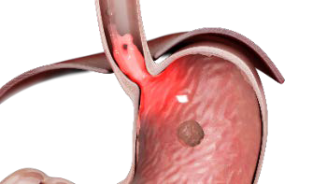
Healthy Valve
GERD Valve

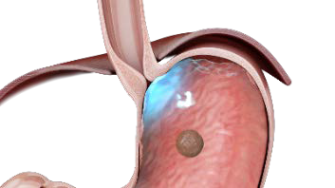

Prevalence & Impact of GERD
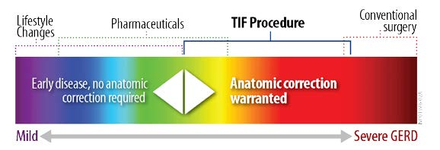
- GERD is the most common gastrointestinal- related diagnosis made by physicians during clinical visits in the U.S.*
- It is estimated that pain and discomfort from acid reflux impacts over 80 million people at least once per month in the U.S.*
- GERD can have a significant impact on a patient’s quality of life through persistent typical and
atypical symptoms, inconsistent sleep patterns, dietary restrictions, additional health care costs and lost productivity from work.*

Treatment of GERD
- Treatment for GERD varies according to the severity of the symptoms and the individual. The following are some examples of how GERD can be treated:
  - Dietary and Lifestyle: Changes in a patient’s diet and lifestyle may help mild GERD sufferers control infrequent symptoms.
  - Over-the-Counter and Prescribed Pharmaceuticals: Some over-the-counter medications, such as proton pump inhibitors (PPIs), can provide temporary relief, but do not treat the underlying anatomical problem or stop the disease from worsening. Evidence continues to mount on use of PPIs. Long-term dependency is now associated with complications including negative impacts throughout the body on the gastrointestinal system, nutrient absorption, bones, kidneys, heart, and shortened lifespans. *
  - Anti-reflux Surgery: Chronic GERD sufferers may benefit from incisionless interventions or laparoscopic surgeries designed to reconstruct the anatomical components of the anti-reflux barrier. This approach restores the body’s normal defense against reflux. Conventional surgery has long been considered an effective solution to treating GERD; however, it frequently introduces negative side-effects such as difficulty swallowing (26%), bloating (36%) and increased flatulence (65%). *
- The goals of any GERD treatment regimen are symptom control, prevention of GERD-related complications and healing of esophagitis, and to help patients get back to life, free of the distraction and discomfort of GERD.

*References: http://www.gerdhelp.com/gerd-references/ NP02380-03

